London Sweets & Bakers

**User** **Guide**

**GROUP** **MEMBERS:**

|  |  |
| --- | --- |
| **Enrolment no** | **Name** |
| **1618603** | **Horia Shereen** |
| **1618869** | **Tehzeeb Fatima** |
| **1620915** | **Hooria** |

**CURRICULUM:** **ACCP** **AI 7144:**

**SEMESTER:** **CPISM**

**FACULTY:**  **MAAZ RAHIM KHAN**

**CERTIFICATE** **OF** **RECOGNITION:**

This certificate is awarded to acknowledge the exceptional efforts and dedication demonstrated in the successful completion of the eProject titled: **London Sweets & Bakers** as part of the **First Semester** in **ACCPAI7144**.

This recognition highlights the creativity, problem-solving abilities, and teamwork that contributed to the project's success. Your commitment to excellence and innovation has set a benchmark for your peers, reflecting your strong passion for learning and development.

Your contributions not only showcase technical proficiency but also emphasize collaboration, critical thinking, and a proactive approach toward achieving goals.

**Presented** **On:** **April** **19,2025**

**Authorized** **Personality:** **SIR** **MAAZ RAHIM** **KHAN**

**ACKNOWLEDGEMENT:**

**Acknowledgment**

We sincerely thank everyone who helped make this project a success.

A special thanks to **Sir Maaz Rahim Khan** for their valuable guidance and support throughout the process.

We are also grateful to our team members for their hard work, dedication, and teamwork, which made this project possible.

Our heartfelt appreciation goes to our families for their love and support, keeping us motivated along the way.

Lastly, we thank everyone who provided us with the resources and opportunities needed to complete this project.

.

**Thank you!**

**PROBLEM** **STATEMENT:**

The ‘London Bakers and Sweets’ is a Sweets and Bakery Items shop. It provides wide variety of products.

The site provides list of products along with the Ingredient and Nutrition details. Consumers can select and choose from the wide range of products

‘London Bakers and Sweets’ is looking to restructure the entire website to provide information and also connect with prospective customers.

**Requirement Specification:**

The Web site is to be created based on the following requirements.

1. The Home Page should be created with proper sections, graphics and with a suitable logo
2. The site should display a menu with following categories:

* About Us
* Products – Sweets
* Products – Bakery
* Gift Hampers
* Contact Us

1. Products should be accompanied with the details, Nutrition value and Ingredient details.
2. It should also be accompanied with Price in DOLLAR [$] and Weight.
3. Gift Hamper should provide details about the gift items and price with weight.
4. ‘About Us’ should provide details of the company and past and upcoming events.
5. There should be a “Contact Us” page which will have the Address of the Company which is as follows and the mail address which when clicked will invoke the local mail client from where they can send an email.

**Guide:**

**Navbar (index.html) – By Horia Shereen**

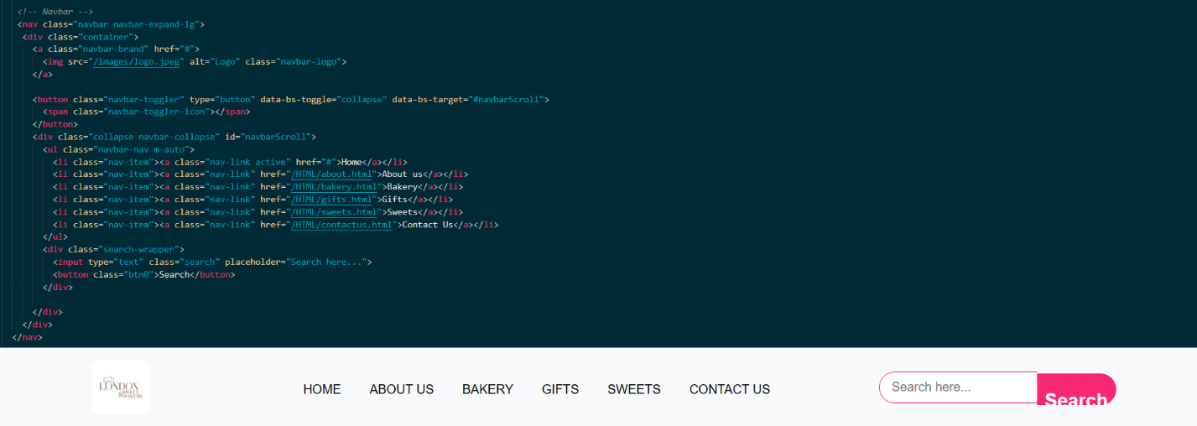

**Main Section (index.html) – By Horia Shereen**

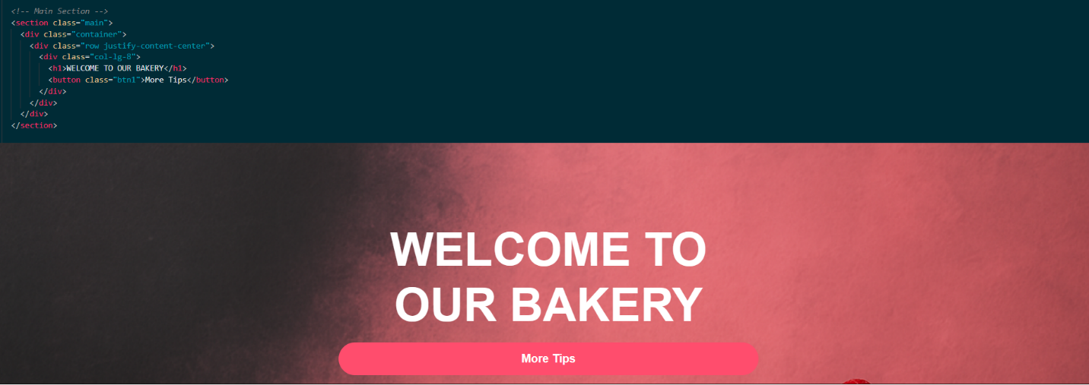

**Popular Items (index.html) – By Horia Moin**

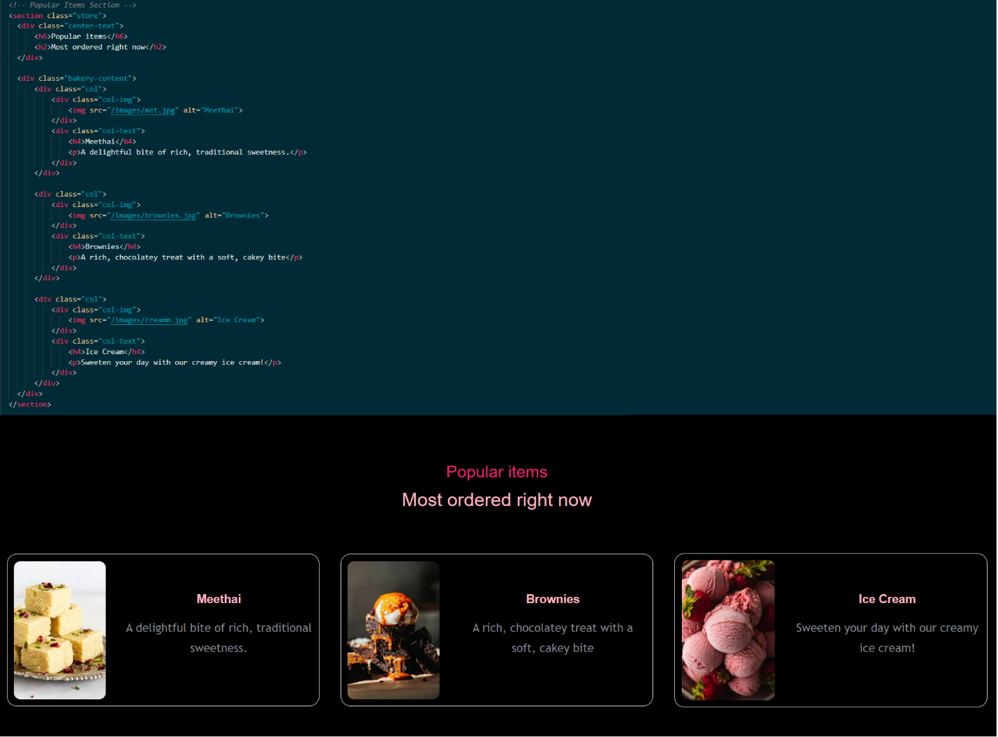

**Categories (index.html) – By Tehzeeb  
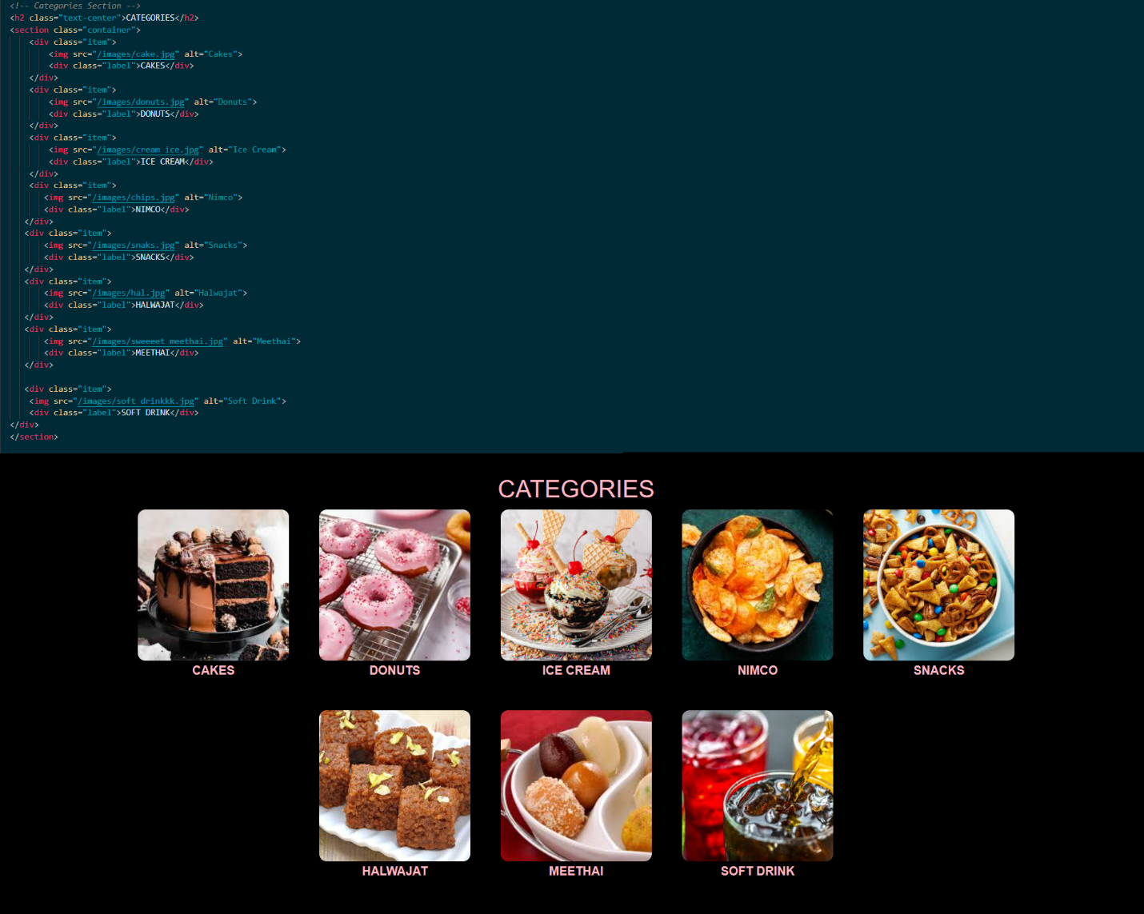**

**About us (index.html) – By Horia Shereen**

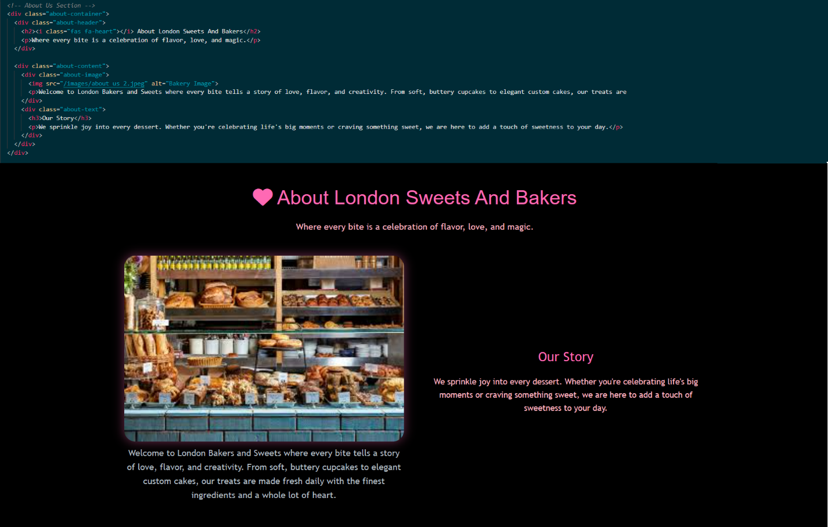

**Contact Us (index.html) – By Horia Shereen**

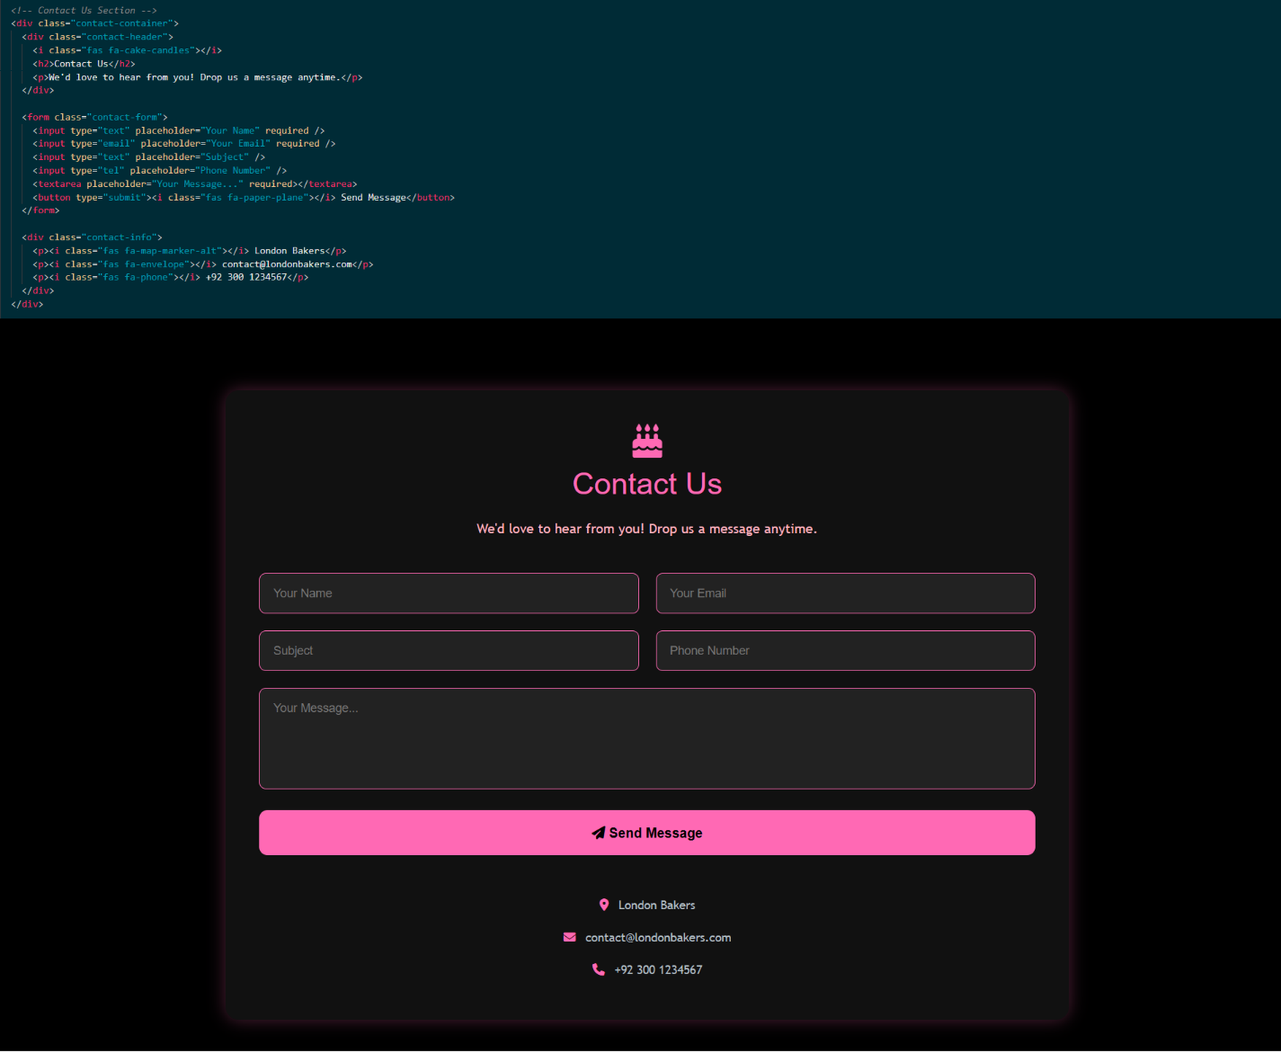

**Footer (index.html) – By Horia Shereen**

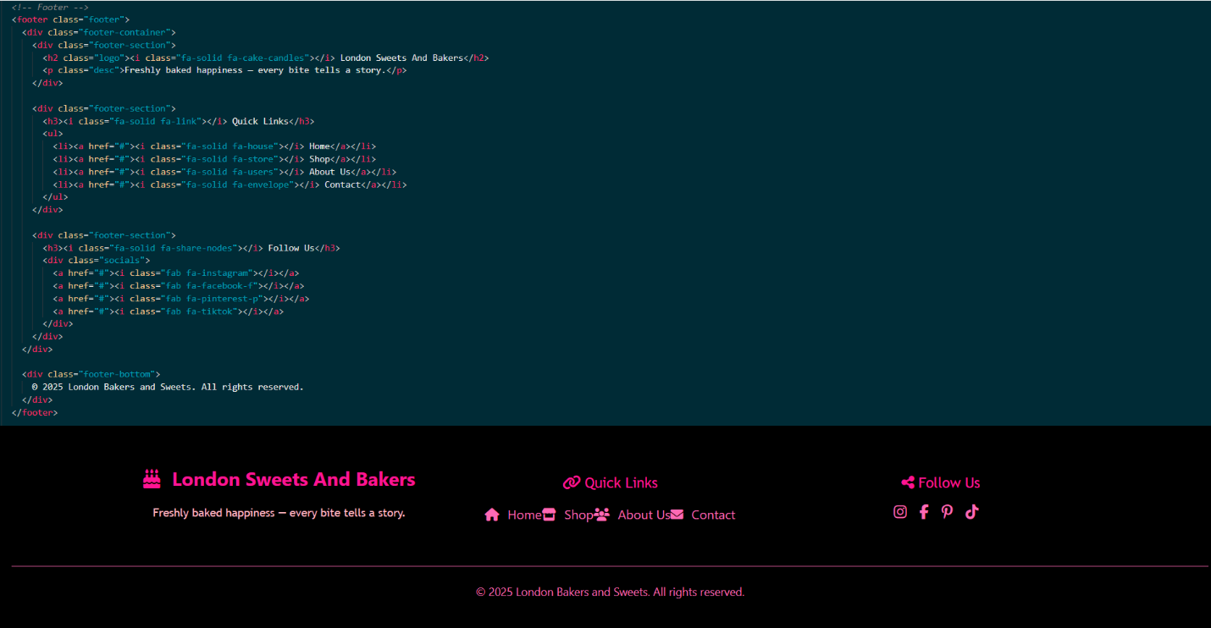

**Snacks Carousel (bakery.html) – By Horia Moin**

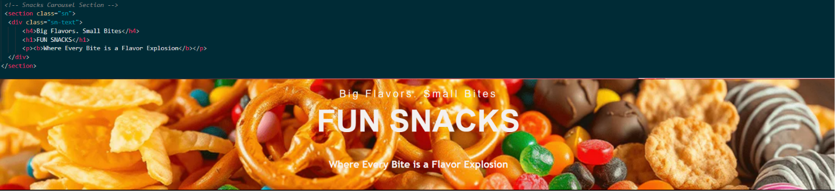

**Card 1 (bakery.html) – By Tehzeeb**

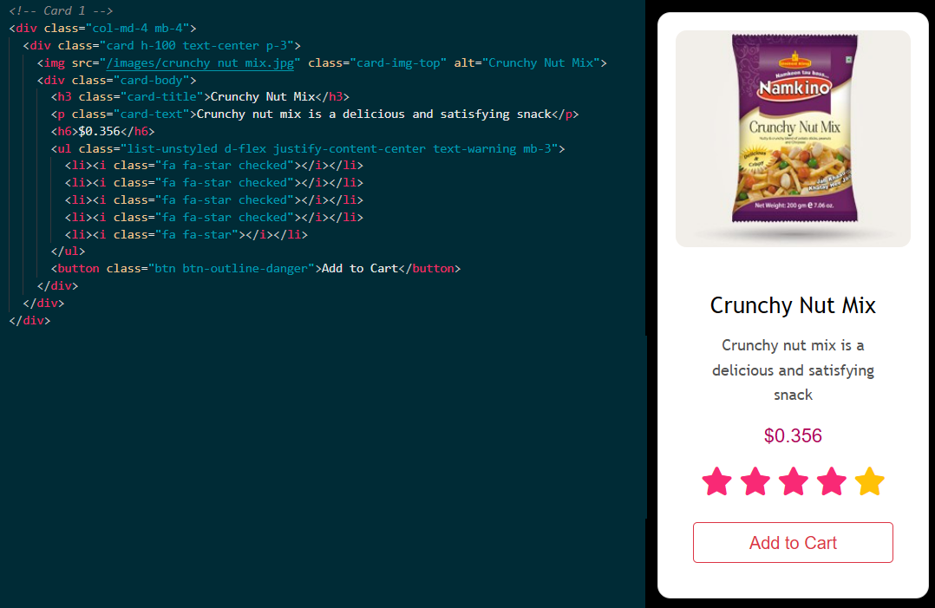

**Card 2 (bakery.html) – By Tehzeeb**

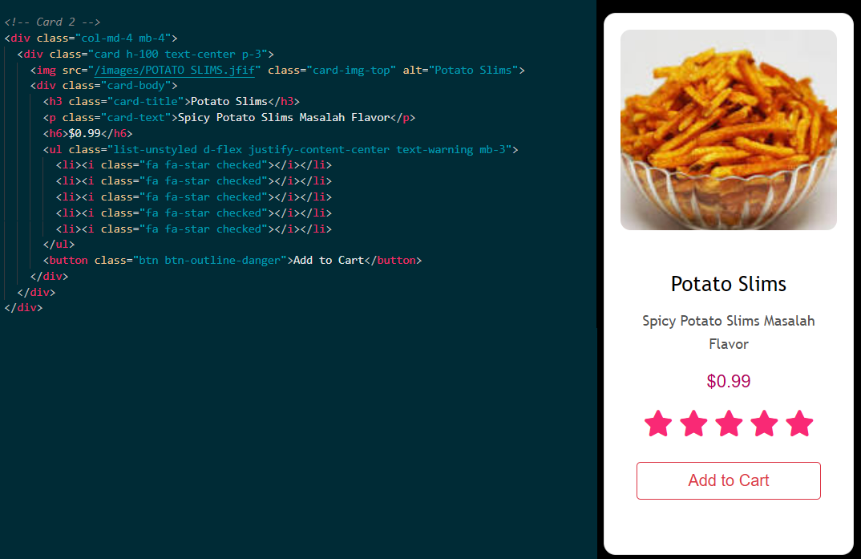

**Card 3 (bakery.html) – By Tehzeeb**

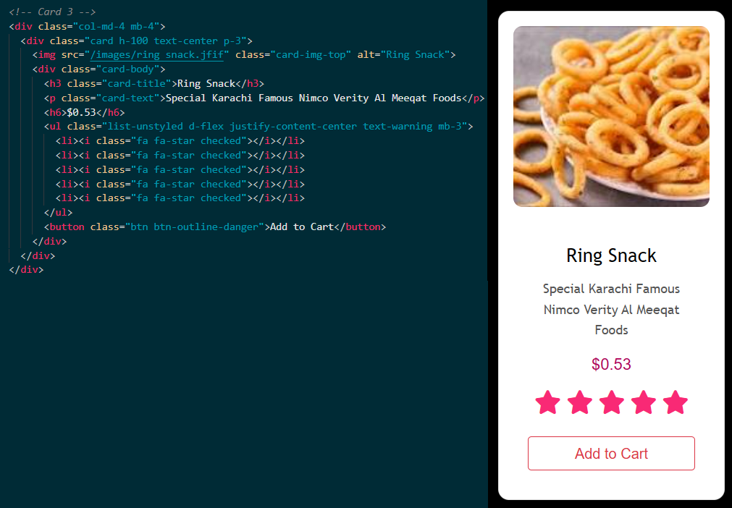

**Gift card section (gifts.html) – By Tehzeeb**

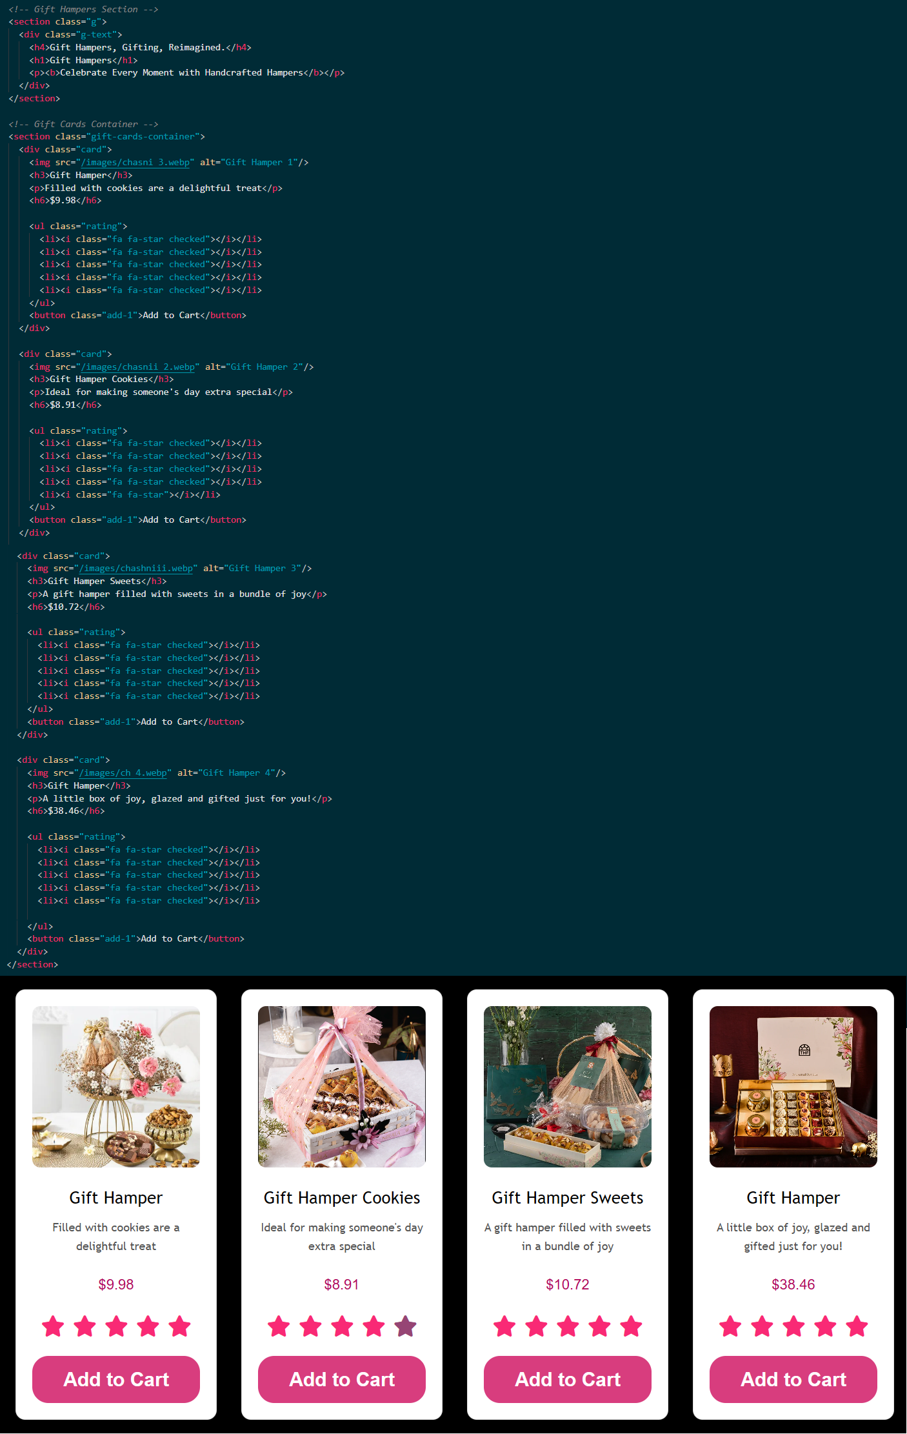

**Cake Card (sweets.html) – By Tehzeeb**

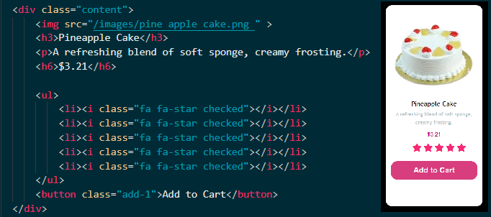

**Ice Cream Card (sweets.html) – By Tehzeeb**

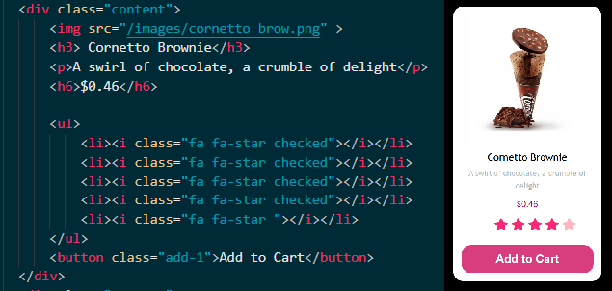

**Mithai Card (sweets.html) – By Tehzeeb  
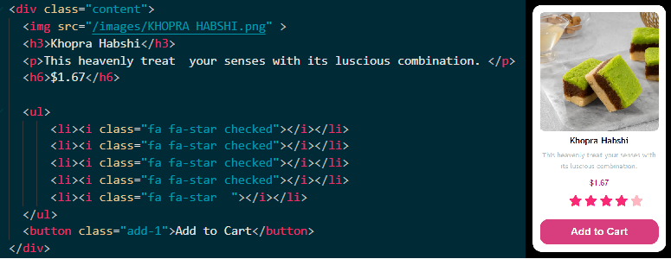**

**Soft Drink Card (sweets.html) – By Tehzeeb  
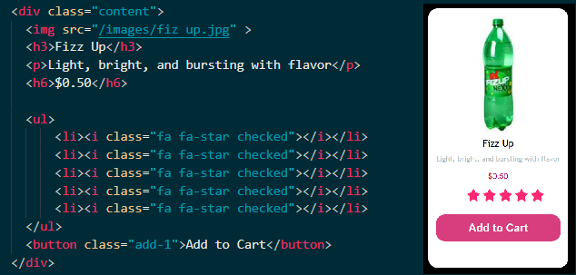**

**Halwa Card (sweets.html) – By Tehzeeb**

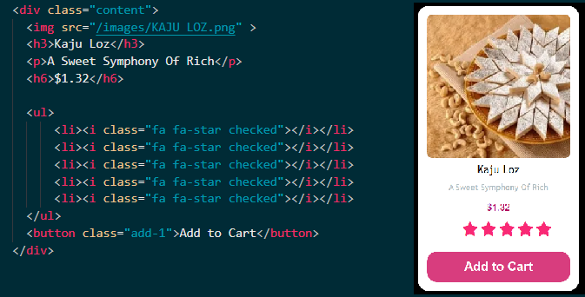

**Donut Card (sweets.html) – By Tehzeeb**

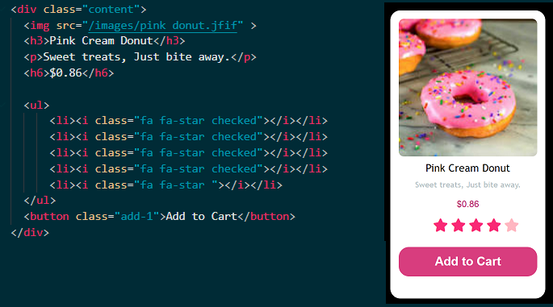

**Home page (index.html): This is the landing page**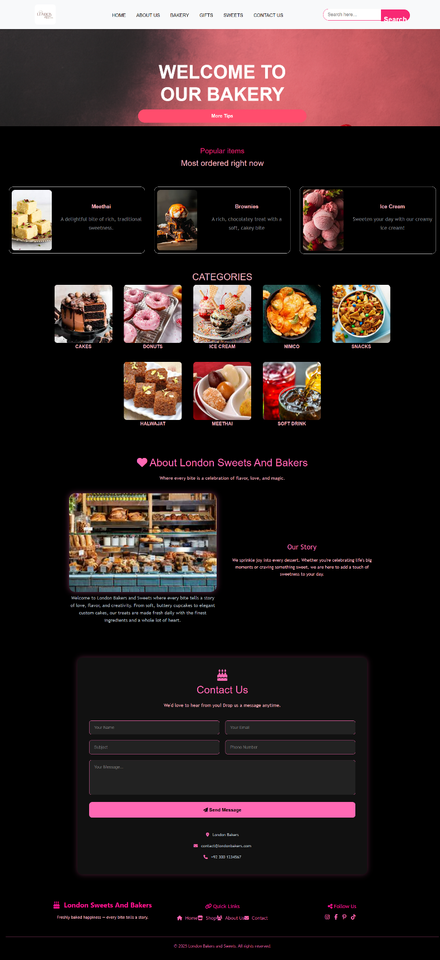

**About Us (about.html): This tells about the bakery and its story**

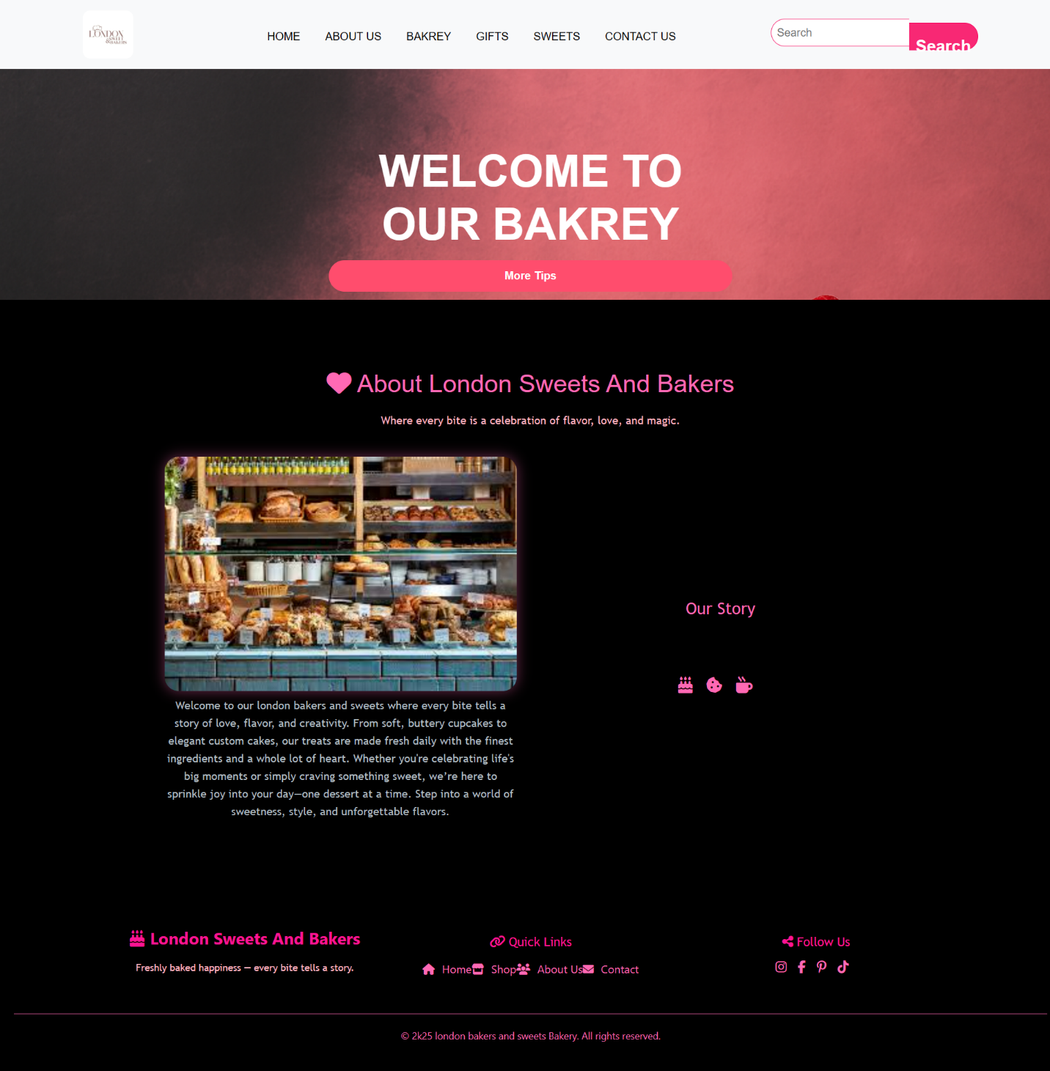

**Bakery (bakery.html): This shows the bakery items**

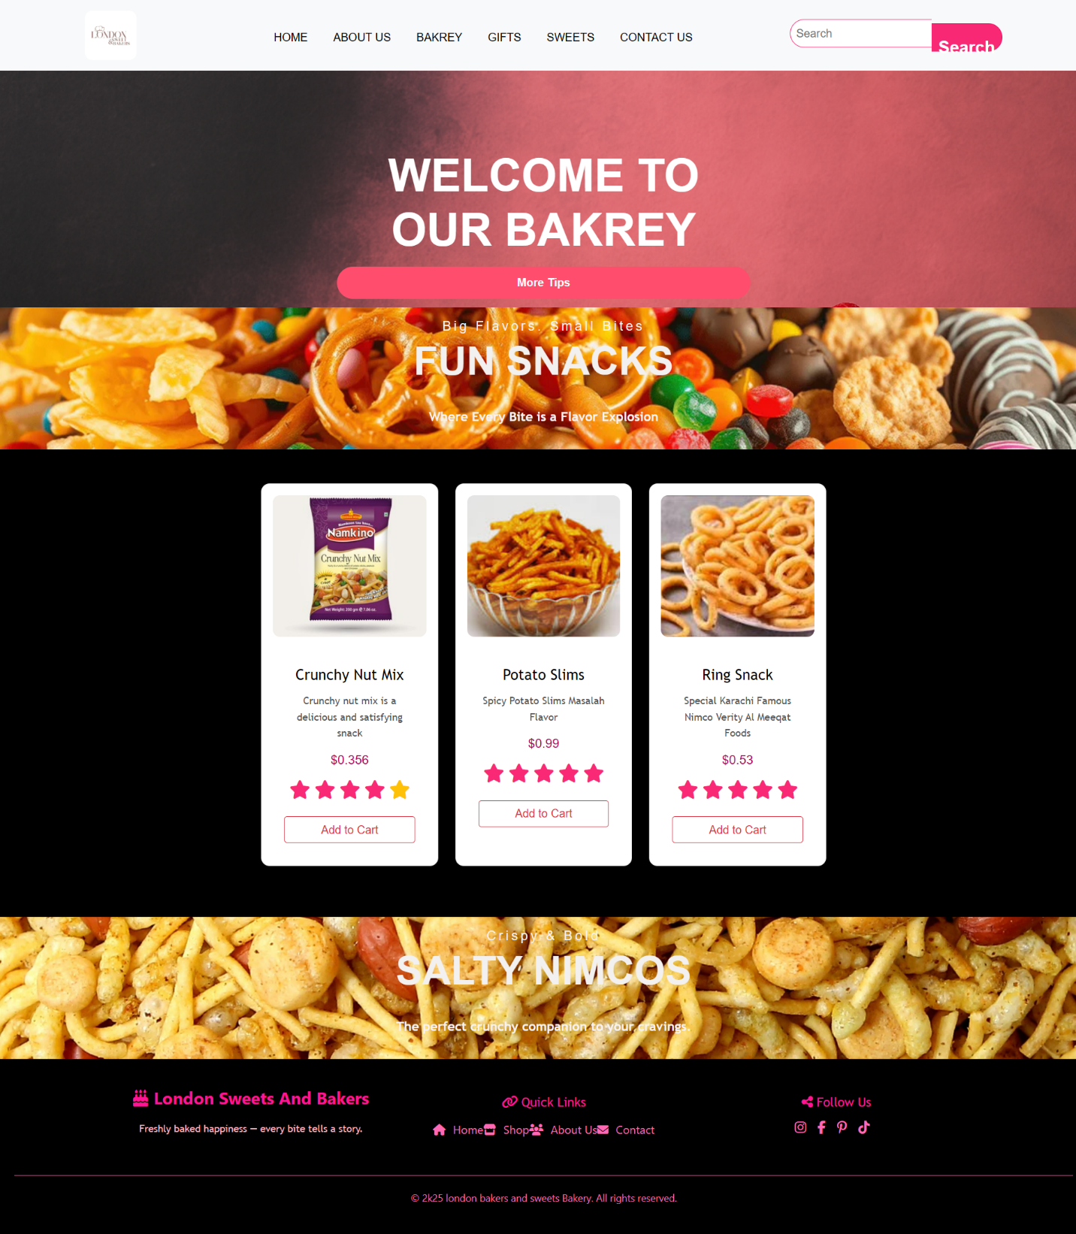

**Gifts (gifts.html): This shows the gifts hampers**

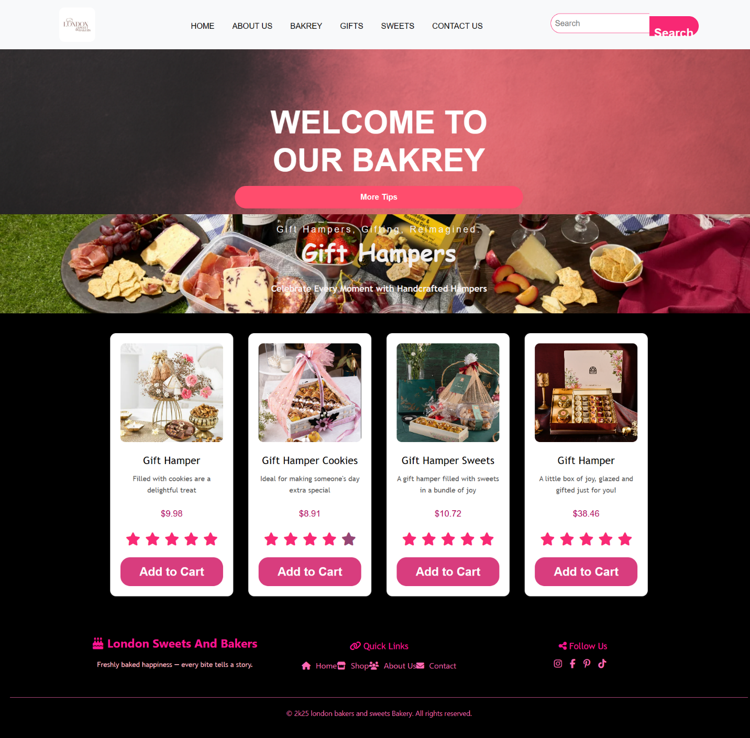

**Sweets (sweets.html): This page is about sweets**

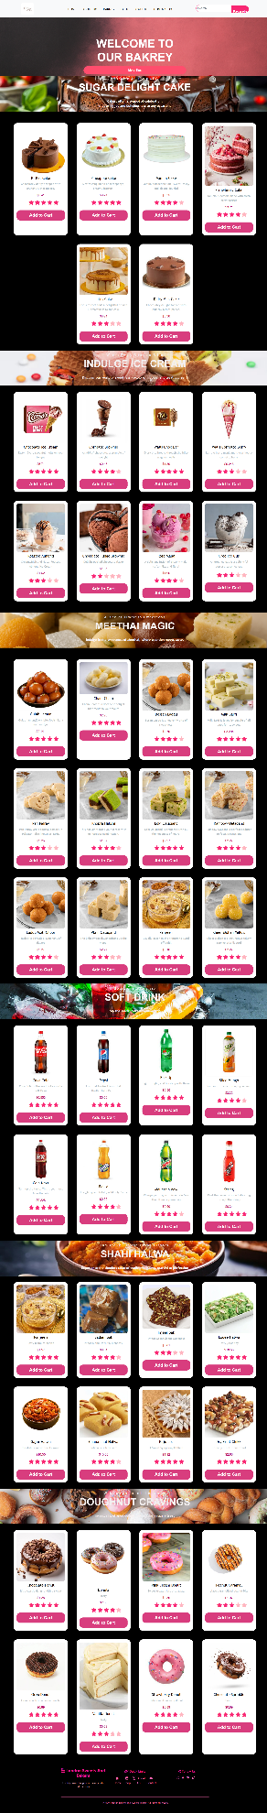

**Contact Us (contactus.html): This page shows how to contact the bakery**

